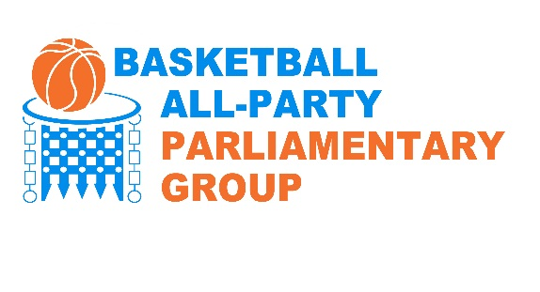

Draft Letter to Local MPs
On Club letter heading

Xxth February 2018

Dear xxxxx, MP

I am pleased to advise you that the APPG Basketball, through Alex Sobel, MP, Lord Wasserman and colleagues, has been able to secure a Backbench debate from the Backbench Business Committee, in Westminster Hall on Tuesday, 20 February, 2018. This is a 90 minute slot beginning at 9:30 am. This relates to the funding of our sport, which engages with our communities in ways few other activities do.

We would very much welcome you supporting and participating in this debate.

As a reminder, I attach to this letter some relevant related information about the sport of basketball in the UK.

We are available for a meeting to discuss these matters, and the significance to your constituents, at your convenience.

Thank you for giving consideration to this matter.

Yours sincerely,

xxxx

Attachment - Information on Basketball in the UK

- Basketball is the second most popular sport (after football) for 11 to 15 year olds, even more popular than riding a bike, according to the DCMS Taking Part survey. It shows that more than 1 in 4 young people in this age group played basketball in the last month, the equivalent of 750,000 Over 65,000 young people also competed in School Games basketball competitions in 2016/17

- Although basketball is most popular with young people, it remains the 3rd largest team sport for adults, larger than Rugby Union, Rugby League, Netball and Hockey. According to the latest Sport England Active Lives survey, over 300,000 adults play at least twice a month.

- Uniquely in mainstream sport, more than half of basketball’s adult participants are from BAME groups. The latest data on ethnicity shows that 58% of adult participants are from BAME groups compared to a national proportion of approximately 10% in the adult population in England.

- In comparison to other team sports, Basketball has a relatively balanced gender split. Taking Part surveys shows that girls make up about 40% of participants aged 11-15, compared, for example, with football at 22%. For adults, approximately one quarter of participants are female, as shown in the Active Lives study, and a similar figure to the 22% of women in Basketball England’s membership.

- Using government Indices of Multiple Deprivation, approximately 17% of Basketball England members live in the most deprived wards, measured by the highest IMD quintile. Much of the outreach work of the clubs and Governing Bodies targets young people in deprived neighbourhoods; for example 22% of Satellite clubs and 44% of Junior NBA schools were located in the most deprived wards. 18% of basketball clubs were located in the most deprived wards, compared to 10% or fewer of Cricket, Rugby, Netball and Hockey clubs

- Charities that use sport for social change regularly use basketball as a lead or priority sport.
For example, Basketball is the second most popular sport in StreetGames doorstep sport programme and is the most popular sport used in Greenhouse Sport’s education and sport programme. Each of these programmes has evidenced improved health and psycho-social outcomes.

However, Basketball is hugely underfunded by government compared to other sports:

- Since 2009 Basketball has had £102 of funding per adult participant, less than half the amount of the next highest comparable sport Netball, which had £205 per adult participant, Hockey received £259 per adult participant and Rugby Union £276 per adult participant. These figures only include Sport England funding; if we include Elite funding from UK Sport, the discrepancies are even greater.

We believe Basketball has a unique case for funding, as it is not just a sport, but also a way to engage disengaged young people, particularly from BAME communities, and offer wider life opportunities, and reduce the potential for involvement in anti-social and criminal activities.

However, Basketball, especially at the elite level across all age groups, is reaching a crisis point in funding, with zero funding for the elite level of our sport from government on offer from April 2018. We believe a change in policy by UK Sport and Sport England is required to ensure a focus not just on Olympic Medals, but the holistic opportunities certain sports, and especially Basketball, offer, particularly to our inner cities and our most deprived communities.

